(Practical side of LED) Pseudo Paper

The light emitting diode (LED) is a Nobel Prize winning invention of the 20th century that has helped redefine energy efficient light emission. Utilizing the optical phenomena of electroluminescence, the LED produces light via a direct source of current, rather than a heated filament or gas. In its simplest form the LED is a pair of semiconductors that consist of conduction and valence bands which allow for free electrons to recombine with electrons holes and release photons. Although the first LEDs were created in the 1920’s, useful applications were not invented until the 60’s, and commercial applications were not available until as recently as the 1990s. [1][2]

The structure of the LED typically consists of Gallium Nitride (GaN), or some other type of crystal structure, doped with impurities. Doping can be either n-type or p-type. The impurities added allow for more states closer the band gap on both bands, thus allowing for easier electron travel across the band gap. When an external voltage is applied to the semiconductors, an electric field is produced and current is formed from the electron recombination. The recombination emits energy as photons. If the semiconductors have an indirect band gap, the energy is released as vibrations, if the semiconductor has a direct band gap, then the energy released is light. GaN is a common semiconductor that can have a direct band gap, hence they are heavily used in LEDs. [1]

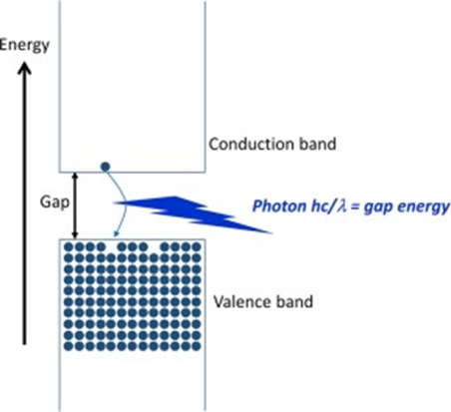

*Figure 1: Demonstration of the basic setup of an LED. The conduction band consists of free electrons while the valence band consists of the electron holes. Electrons jump the energy gap by releasing energy in the form of photons. The amount of energy needed to jump is proportional to the wavelength of the photon, thus the band gap can be used to set the color of the LED. [1]*

In constructing our model of an LED we must consider a few factors, mainly the parameters we want to set, the assumptions well make, and the ultimate goal of the model. Firstly, there are many types of LEDs to consider. I’ve only described the most basic setup of an LED (which variations on this setup were used for red, green, and the blue LED). If we wanted to model the white LED, we would have to use combination of the three colored LEDs, or the phosphorus lamp invention. There also exist high power, organic, or AC LEDs. In terms of semiconductors GaN is a common type to use, however there exist others, such as phosphorus and plenty of other types of GaN alloys. [1][3]

For this model I believe it will suffice to model just a single colored LED. For simplicity of the model well use GaN with p and n doping. The goal of model could be many things, however a few main outputs that we could attempt are the efficiency of the LED and the color (or color spectrum) of emitted photons. We’ve already found a few equations that can help guide us in this endeavor.

1. N = Pq/(I\*h\*v\*A)
2. Φe = nex \*If \*ℏv

Where for equation one; N is the efficiency of an LED, P is optical power, I is injected current, A is area of LED die, q is charge of electron, ℏ is Planck’s constant and v is frequency of emitted light; and for equation two ℏ is Planck’s constant and v is frequency of emitted light If is the operating current and nex is the external quantum efficiency. In these equations, some of the variables will be easy to get or model, however some others will require more effort to construct or may not be possible in terms of this project. It’s important to know that much of the research for LED is experimental and empirical, without actual lab data out model is already more restrain than a purely theoretical phenomena, although not impossible by any means.

Sources:

[1] LEDs for lighting: Basic physics and prospects for energy savings - Bruno Gayral

[2] The role of ITO resistivity on current spreading and leakage in InGaN/GaN light emitting diodes - V.Sheremet M.Genç M.Elçi N.Sheremet A.Aydınlı I.Altuntaş K.Ding V.Avrutin Ü.Özgür H.Morkoç

[3] White light emitting diodes with super-high luminous efficacy -Yukio Narukawa, Masatsugu Ichikawa, Daisuke Sanga, Masahiko Sano and Takashi Mukai